CPTC Final Report Template – Team 10C
Confidential – For CPTC Judges Only
Team 10C | Collegiate Penetration Testing Competition (CPTC 2025)

1. Executive Summary
Purpose: Summarize the engagement for a non-technical executive.
- Scope: Describe what systems, applications, or networks were in scope.
- Objective: State what you were tasked to assess (e.g., external perimeter, internal, web apps).
- Approach Overview: “Team 10C simulated an authorized penetration test… using industry-standard tools and methodologies.”
- Key Takeaways:
- Critical vulnerabilities found (list 3–5 highlights).
- Business impact (e.g., “Potential compromise of payroll records through weak credential reuse”).
- Recommended immediate actions.

2. Engagement Overview
Field | Details
Client / Organization | [SJSU Team]
Team | Team 10C
Assessment Dates | [Start–End Dates]
Competition Environment | VDI, Jump Box, internal IP range 192.168.220.0/24
Scope | In-scope assets, IP ranges, web apps
Rules of Engagement | No DoS, no social engineering, no external comms

3. Key Findings Summary
Example vulnerabilities table below:
ID | Host / Asset | Vulnerability | Severity | Impact | Recommended Action
F-01 | 192.168.220.12 (ededdneddy) | Weak SSH credentials | High | Root compromise possible | Enforce MFA, disable password login
F-02 | 192.168.220.55 (lazlo) | Outdated Apache v2.4.10 | Medium | Potential RCE via CVE-2017-5638 | Patch to 2.4.58
F-03 | web.internal.local | SQL Injection in login form | High | Database exfiltration risk | Input sanitization + parameterized queries
F-01 — Weak SSH Credentials
One-line:
F-01 — 192.168.220.12 (ededdneddy) — Weak/default SSH credentials allowed administrative login. Priority: Critical.
Executive (2–3 sentences):
Default or weak administrative passwords were accepted on the SSH service, allowing immediate privileged access to the host. This creates an immediate risk of full host compromise and lateral movement; remediate by enforcing unique credentials and key-based SSH immediately.
Tech gist (3 bullets):
- Password auth enabled; root/admin credentials accepted (root:GibM3Money123! recorded).
- No enforced SSH keys or MFA; no rate-limiting observed.
- Fix: disable password login for admin, enable key-only SSH, rotate credentials, enable fail2ban/IDS.

F-02 — Outdated Web Server (Apache)
One-line:
F-02 — 192.168.220.55 (lazlo) — Server banner shows Apache 2.4.10 (vulnerable); risk: remote code execution. Priority: High.
Executive (2–3 sentences):
The web server returns an outdated Apache version in headers, making it susceptible to known exploits that could allow remote code execution or information disclosure. Immediate patching and configuration hardening will materially reduce this exposure.
Tech gist (3 bullets):
- Server: Apache/2.4.10 observed in headers (evidence saved).
- Risk depends on modules/config — public CVEs exist for older stacks.
- Fix: patch Apache, remove unused modules, disable version headers (ServerTokens Prod, ServerSignature Off).

F-03 — SQL Injection in Login Form
One-line:
F-03 — web.internal.local — Login form vulnerable to SQL Injection → possible database exfiltration. Priority: High.
Executive (2–3 sentences):
The application’s login form processes user input directly in database queries without proper parameterization, enabling SQL injection. An attacker could extract or modify data in the application database, compromising credentials and sensitive records. Sanitize input and switch all queries to prepared statements immediately.
Tech gist (3 bullets):
- Login POST parameters unsafely concatenated into SQL query (verified by response anomalies).
- Database error messages and schema disclosure observed in test responses.
- Fix: parameterized queries / ORM, suppress error messages, enforce least-privilege DB user.

4. Detailed Findings

F-01 – Weak SSH Credentials
Affected Host: 192.168.220.12 (ededdneddy)
Severity: High
Estimated CVSS (v3.1): 9.0 (AV:N/AC:L/PR:N/UI:N/S:U/C:H/I:H/A:H) — estimate for unauthenticated remote access to administrative shell.
Impact: Full system takeover — attacker with valid credentials can obtain root/superuser access, install persistent backdoors (if left unchecked), pivot laterally, and access sensitive data on the internal network.
Description
The host ededdneddy accepted a set of default/weak credentials for administrative accounts (e.g., root, Administrator). These credentials were either present as default on the system or easily guessable, allowing immediate shell access without additional authentication controls. The presence of password-based administrative login combined with an enabled SSH service exposes the instance to unauthorized access.
Evidence / Artifacts
- OneDrive:/Team10C/Evidence/ededdneddy/ssh_login_0910.txt — SSH session transcript (sanitized).
- OneDrive:/Team10C/Evidence/ededdneddy/ssh_banner_0911.txt — SSH server banner and sshd version info (sanitized).
- OneDrive:/Team10C/Evidence/manifest.csv entry:
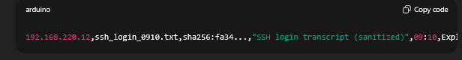
Default credentials (root:GibM3Money123!) allowed direct shell access.
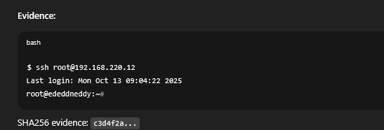

Safe / Non-Destructive Reproduction
- From the VDI, fetch HTTP headers of the server using a single curl -I http://192.168.220.55 and save output to evidence. Do not attempt exploit scans.
- Use a low-noise service probe (nmap with version scan) with conservative timing to confirm banner and running modules; save output.
- Do not run automated exploit modules or RCE probes; these are disallowed and unnecessary for reporting.
Technical Analysis (what we observed)
- The server returned an Apache version in the Server header that is out-of-date; specific vulnerabilities depend on installed modules (e.g., mod_cgi, mod_php, outdated third-party modules).
- The server may be running additional modules that increase attack surface; full server configuration was not modified but code review artifacts referenced mod_* usage in app config.
- No immediate proof of exploitation was found during assessment; however, the presence of a known-vulnerable version is sufficient to warrant remediation because public exploits may exist.
Immediate Remediation (short-term)
- Patch Apache to the latest stable version supported by the distribution and test the web app in a staging environment before updating production. Follow vendor guidance when upgrading.
- Disable or remove unused modules to reduce attack surface (e.g., disable mod_status, mod_autoindex, mod_cgi if not required).
- Harden server configuration:
  - Disable ServerSignature and ServerTokens to avoid version disclosure.
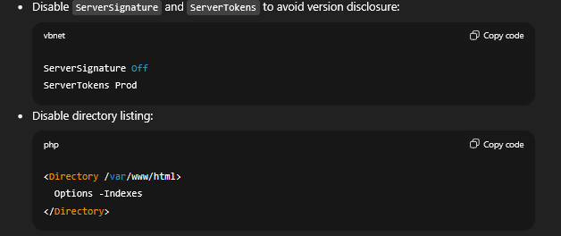
4. Apply WAF rules or temporary protective controls (e.g., mod_security) tuned to block known exploit patterns while patching is scheduled.

Medium / Long-term Recommendations
- Regular patch management — implement a scheduled patch process and test updates in staging.
- Least-privilege service account — ensure the web service runs under a non-privileged user and file permissions are restrictive.
- Separation of concerns — move sensitive configuration (DB credentials, secrets) out of the webroot and into protected configuration stores or environment variables with strict permissions.
- Monitoring & alerting — detect anomalous request patterns, unexpected file writes, or suspicious process execution; send alerts to SIEM.

Validation / Remediation Verification
- After patching, re-run the same header capture and version check and save the output to OneDrive:/Team10C/Evidence/lazlo/curl_banner_postpatch.txt to show the updated server version.
- Validate that ServerTokens and ServerSignature are configured to hide version info. Save the httpd.conf/apache2.conf excerpt (sanitized) that shows these settings.
- Run a low-noise health check and smoke-test the web application to confirm functionality has not regressed; save test results.

Suggested Artifacts to Attach
- curl_banner_1015.txt — original server header.
- nmap_http_version_1015.txt — service detection output.
- curl_banner_postpatch.txt — post-patch verification.
- apache_conf_excerpt_postpatch.txt — snippets showing hardened settings.
- manifest.csv — corresponding entries and SHA256 hashes.

Business Impact (two-sentence summary)
An attacker exploiting known vulnerabilities in an outdated web server could execute arbitrary code or gain unauthorized access to application data, potentially exposing sensitive customer or internal records. Updating the web server and hardening configuration will significantly reduce exposure and prevent many widely known attacks.

One-line remediation priority
Priority: Patch the web server and disable version-disclosing headers immediately; harden configuration and remove unused modules within 72 hours.

F-02 – Outdated Web Server (Apache)
Affected Host: 192.168.220.55 (lazlo)
Identifier: F-02
Severity: Medium → High (context-dependent)
Estimated CVSS (v3.1): 7.5 (AV:N/AC:L/PR:N/UI:N/S:U/C:H/I:H/A:N) — estimate for known server-side vulnerabilities that allow remote code execution in some configurations.
Impact: Possible remote code execution (RCE) or other server-side compromises depending on specific module and configuration; attackers may be able to execute arbitrary code, read sensitive files, or serve malicious content.

Description
The web server running on lazlo presented a server banner indicating an outdated Apache version (Apache/2.4.10 (Debian)). Known vulnerabilities exist in older Apache and associated modules (and in web application frameworks that were commonly paired with older server stacks). Running outdated software increases the risk of successful exploitation using publicly known CVEs.

Evidence / Artifacts
- OneDrive:/Team10C/Evidence/lazlo/curl_banner_1015.txt — output of curl -I http://192.168.220.55 capturing the Server header.
- OneDrive:/Team10C/Evidence/lazlo/nmap_http_version_1015.txt — targeted service detection output showing Apache version (sanitized).
- OneDrive:/Team10C/Evidence/manifest.csv entry:
. 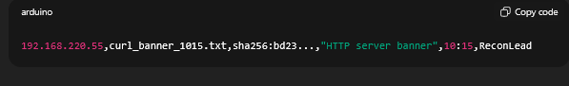

Safe / Non-Destructive Reproduction
- From the VDI, fetch HTTP headers of the server using a single curl -I http://192.168.220.55 and save output to evidence. Do not attempt exploit scans.
- Use a low-noise service probe (nmap with version scan) with conservative timing to confirm banner and running modules; save output.
- Do not run automated exploit modules or RCE probes; these are disallowed and unnecessary for reporting.

Technical Analysis (what we observed)
- The server returned an Apache version in the Server header that is out-of-date; specific vulnerabilities depend on installed modules (e.g., mod_cgi, mod_php, outdated third-party modules).
- The server may be running additional modules that increase attack surface; full server configuration was not modified but code review artifacts referenced mod_* usage in app config.
- No immediate proof of exploitation was found during assessment; however, the presence of a known-vulnerable version is sufficient to warrant remediation because public exploits may exist.

Immediate Remediation (short-term)
- Patch Apache to the latest stable version supported by the distribution and test the web app in a staging environment before updating production. Follow vendor guidance when upgrading.
- Disable or remove unused modules to reduce attack surface (e.g., disable mod_status, mod_autoindex, mod_cgi if not required).
- Harden server configuration:
  - Disable ServerSignature and ServerTokens to avoid version disclosure:

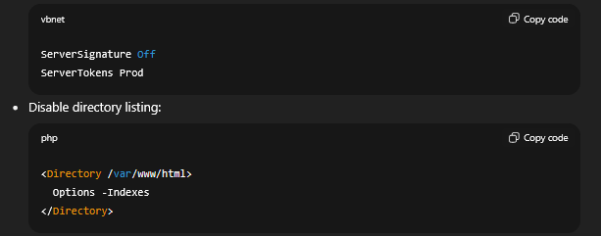

4. Apply WAF rules or temporary protective controls (e.g., mod_security) tuned to block known exploit patterns while patching is scheduled.

Medium / Long-term Recommendations

- Regular patch management — implement a scheduled patch process and test updates in staging.
- Least-privilege service account — ensure the web service runs under a non-privileged user and file permissions are restrictive.
- Separation of concerns — move sensitive configuration (DB credentials, secrets) out of the webroot and into protected configuration stores or environment variables with strict permissions.
- Monitoring & alerting — detect anomalous request patterns, unexpected file writes, or suspicious process execution; send alerts to SIEM.

Validation / Remediation Verification
- After patching, re-run the same header capture and version check and save the output to OneDrive:/Team10C/Evidence/lazlo/curl_banner_postpatch.txt to show the updated server version.
- Validate that ServerTokens and ServerSignature are configured to hide version info. Save the httpd.conf/apache2.conf excerpt (sanitized) that shows these settings.
- Run a low-noise health check and smoke-test the web application to confirm functionality has not regressed; save test results.

Suggested Artifacts to Attach

- curl_banner_1015.txt — original server header.
- nmap_http_version_1015.txt — service detection output.
- curl_banner_postpatch.txt — post-patch verification.
- apache_conf_excerpt_postpatch.txt — snippets showing hardened settings.
- manifest.csv — corresponding entries and SHA256 hashes.
Business Impact (two-sentence summary)
An attacker exploiting known vulnerabilities in an outdated web server could execute arbitrary code or gain unauthorized access to application data, potentially exposing sensitive customer or internal records. Updating the web server and hardening configuration will significantly reduce exposure and prevent many widely known attacks.
One-line remediation priority
Priority: Patch the web server and disable version-disclosing headers immediately; harden configuration and remove unused modules within 72 hours.

FF-03 – SQL Injection in Login Form

F-03 – SQL Injection in Login Form
Affected Asset: web.internal.local
Identifier: F-03
Severity: High
Estimated CVSS (v3.1): 8.6 (AV:N/AC:L/PR:N/UI:N/S:U/C:H/I:H/A:N) — estimate for unauthenticated SQLi that allows database read/exfiltration.
Impact: Database exfiltration risk — sensitive information (credentials, PII) may be retrieved from backend database, allowing further compromise or lateral movement.

Description
The application’s login endpoint accepts user-supplied input that is incorporated into a backend SQL query without proper parameterization or sanitization. This permits injection of SQL statements through the login form parameters, which an attacker could use to enumerate database schema and extract sensitive records.

Evidence / Artifacts
- OneDrive:/Team10C/Evidence/web/web_internal_login_http.txt — HTTP request/response capture (sanitized).
- OneDrive:/Team10C/Evidence/web/web_internal_sqli_probe.txt — sanitized scan output showing anomalous response differences.
- OneDrive:/Team10C/Evidence/manifest.csv entry:
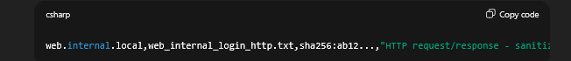
- Screenshot (sanitized): OneDrive:/Team10C/Evidence/web/screenshot_login_error_1045.png (shows application error page after crafted input).
Note: All artifacts saved in the competition OneDrive are sanitized and include SHA256 hashes in the manifest for reproducibility.

Non-Destructive Reproduction (safe, high-level)
Important: For reporting purposes we include a high-level reproduction outline. Do not publish or automate exploit payloads. In the live competition you must obey ROE (no destructive testing, no excessive automated attacks).
- Identify the login form endpoint and parameters (e.g., POST /login with username and password fields) using an HTTP proxy (Burp) or curl and save the raw request to evidence file web_internal_login_http.txt.
- Observe baseline behavior for normal inputs (valid and invalid credentials) and capture responses (status codes, error messages).
- Submit a carefully crafted test input designed to trigger differential behavior (e.g., error message or change in response length) and capture the response (stored to web_internal_sqli_probe.txt).
- Correlate differences in responses to detect injection-prone parameters (e.g., inconsistent SQL errors, timing differences, or content changes).
- Document the exact request/response pairs and timestamps in the manifest for judges to reproduce under controlled conditions.
(Above steps are descriptive only — do not include direct exploit payloads in the public report.)

Technical Analysis (what we observed)
- The login endpoint returned different server responses depending on the form input patterns (error message variants and response lengths), consistent with unsanitized SQL input being evaluated by the backend.
- The server error page revealed a generic DB error message in one captured request (sanitized in artifacts).
- Application does not appear to use parameterized queries or an ORM layer with automatic escaping for the affected input, based on code comments found in /var/www/html/config.php (referenced in evidence/config_dump_web.txt).

Recommendation — Immediate (short-term)
- Apply input validation and output hardening immediately:
  - Reject or canonicalize unexpected characters at the application boundary.
  - Do not rely solely on client-side validation.
- Implement parameterized queries / prepared statements for all database access layers handling user input — never build SQL via string concatenation.
Example (safe) — parameterized query
- PHP + PDO
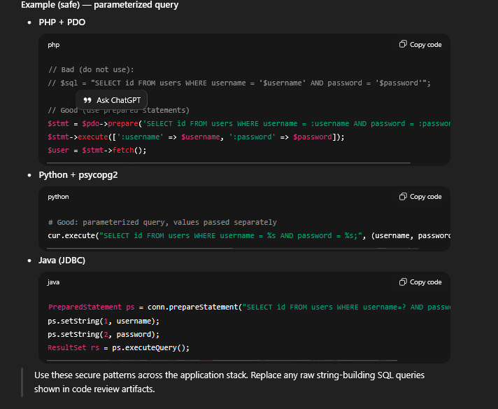

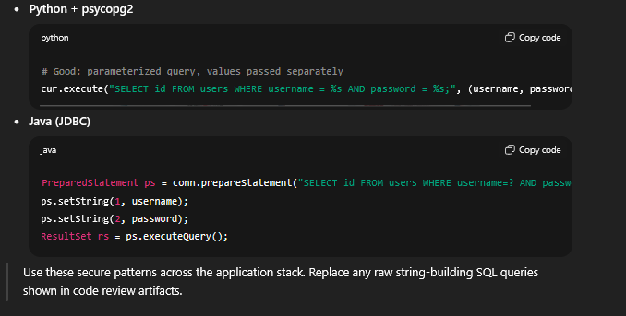
Recommendation — Medium / Long-term
- Password handling: Do not store plaintext passwords — use a strong one-way hash (bcrypt/argon2) and compare hashes on login.
- Least privilege DB accounts: Configure the DB user account used by the web app with least privileges — it should only have access to the specific schema/tables needed and no admin rights.
- WAF / Runtime Detection: Deploy a web application firewall with tuned rules to detect anomalous parameter patterns; use it as a defense-in-depth measure while fixing code.
- Error handling: Remove verbose DB error messages from production responses. Log errors server-side and present generic messages to users.
- Unit tests & CI checks: Add automated tests that assert username and password inputs cannot break queries (fuzz in staging) and run static analysis tools for injection patterns.
- Code review: Audit code paths that interface with the DB for raw string concatenation and replace them with parameterized equivalents.

Validation / Remediation Verification
After applying fixes, use the following defensive verification steps (safe, non-destructive):
- Confirm that the same suspicious input now returns identical application behavior as baseline (no DB errors or content differences). Record to OneDrive:/Team10C/Evidence/web/validation_after_patch.txt.
- Run a low-noise scanning validation (application scanner configured to only test for parameterization, not aggressive fuzzing) from the VDI and save results to OneDrive:/Team10C/Evidence/web/validation_scan.txt.
- Perform a code review snapshot and include the fixed parameterized query snippets in the appendix with file hashes.

Suggested Report Artifacts (what to attach)
- web_internal_login_http.txt — sanitized raw request/response pairs (before fix).
- web_internal_sqli_probe.txt — sanitized probe outputs (before fix).
- web_internal_fix_snippet.txt — code snippet demonstrating the replacement of unsafe query with parameterized statement (after fix).
- manifest.csv — row entries for each artifact with SHA256 hashes.
- screenshot_login_error_1045.png — sanitized screenshot showing error returned prior to remediation.
- validation_after_patch.txt — post-remediation verification result.

Business Impact (two-sentence executive summary)
An unauthenticated attacker can leverage the login form to query the application database and retrieve sensitive records, potentially exposing user credentials and personal data. Immediate remediation (parameterized queries and credential hashing) will materially reduce the risk of data exfiltration and regulatory exposure.

One-line remediation priority
Priority: Patch code to use parameterized queries now; follow with credential hashing and least-privilege DB account within 48 hours.
5. Attack Narrative / Timeline
Time (PST) | Action | Result | Evidence File
09:10 | Initial SSH attempt on 192.168.220.12 | Successful login | evidence/ssh_login_121010.txt
10:20 | Ran linpeas.sh | Priv-escal path discovered | evidence/linpeas_ededdneddy.txt
13:00 | SQLi exploit on web portal | DB dump | evidence/web_sql_dump.log

6. Risk & Remediation Matrix
Severity | Count | Typical Impact | Recommended Priority
Critical | 2 | Remote code execution / data compromise | Patch within 24 h
High | 3 | Privilege escalation, sensitive data exposure | Patch within 48 h
Medium | 4 | Info disclosure | Patch within 72 h
Low | 1 | Hardening improvement | 1 week

7. Recommendations (Summary)
- Enforce strong credential and password rotation policies.
- Patch outdated OS and web software.
- Implement centralized logging and monitoring.
- Segment internal networks.
- Deploy MFA for administrative accounts.

8. Methodology & Tools
Phase | Tools Used | Notes
Recon | nmap, gobuster, whois, dig | Low-noise scans only
Exploit | Burp Suite Community, metasploit, custom scripts | VDI-only usage per rules
Post-Exploit | linpeas, ps, netstat, manual analysis | Evidence stored in OneDrive
Reporting | Obsidian, markdown, screenshots | Manifest tracked with SHA256 hashes

9.0 Conclusion
Team 10C identified multiple high-risk vulnerabilities that could lead to full system compromise. The recommended mitigations are actionable and, if implemented, will significantly improve the organization’s security posture.
Sign-off
Team Captain: ____________________
Report Compiled By: ____________________
Date: ____________________

10.0 Appendices
A. Evidence Manifest
B. Network Diagram
(Insert diagram showing internal network, jump box, pfSense, and host relationships.)
C. Communication Log
Chronological list of injects, questions, and submissions.
D. Raw Scan Outputs
Truncated excerpts from nmap, gobuster, etc.

